CENWP-OD-B 17 July 2023

MEMORANDUM FOR THE RECORD

SUBJECT: 23BON059 MFR Lamprey Mortalities WA Shore UMTJ RB2

On the morning of 17 July, Project Biologists discovered two Pacific Lamprey mortalities in the Washington Shore UMTJ Rest Box #2. The fish were scanned for PIT tags, inspected, and returned to the river.
- Species – Pacific Lamprey (Entosphenus tridentatus)
- Origin – Unknown
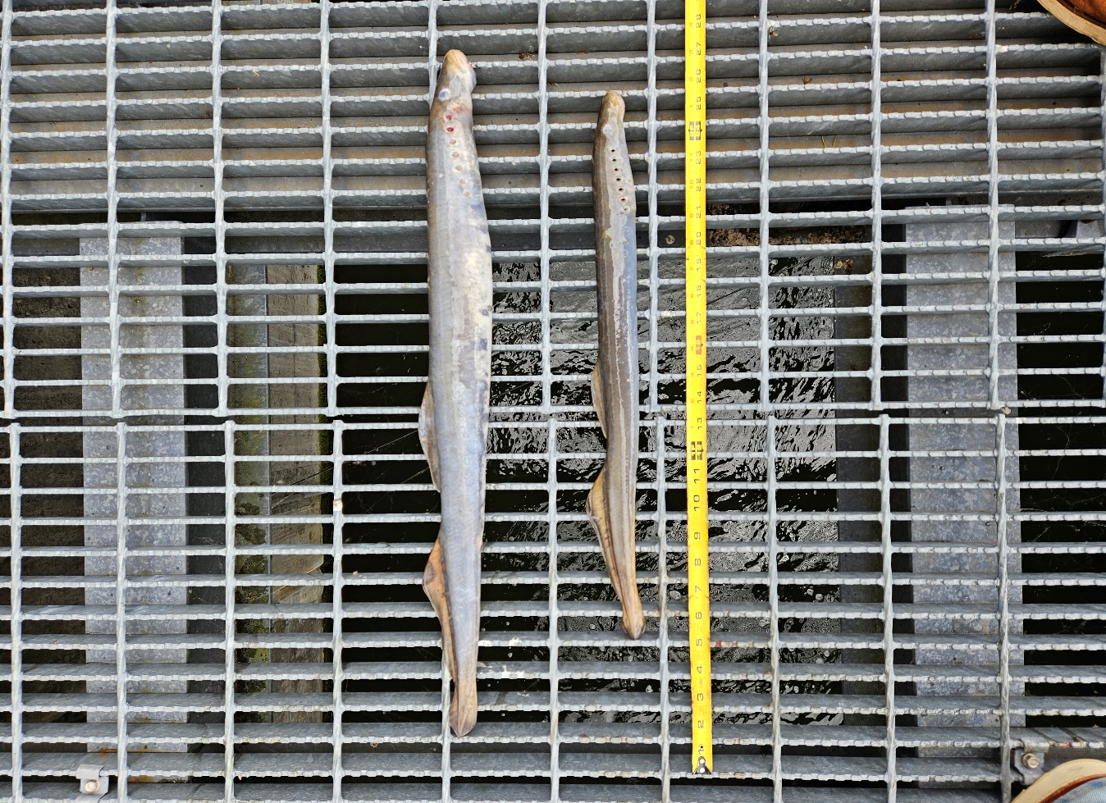
- Length – 74.7 cm
- Marks and tags – None
- Marks and Injuries found on carcass – None
- Cause and Time of Death – Unknown
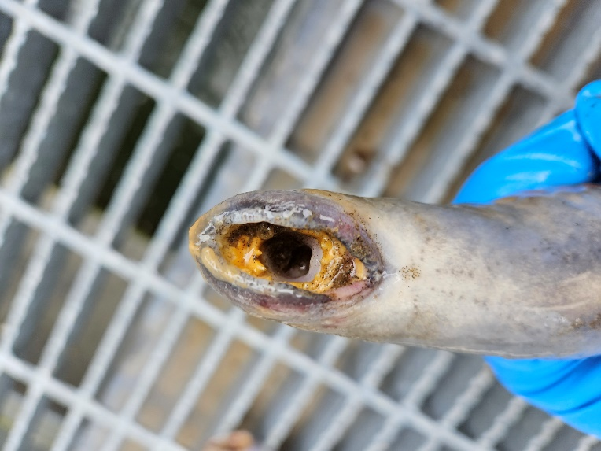
- Future and Preventative Measures – None

Sincerely,
Bonneville Project Fisheries

